Pls contact us :35007117@ qq.com
----------------------------------------------------------
reed switch module
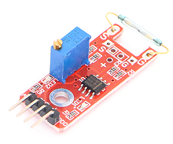

reed switch module can connect UNO R3 PIN13, make magnetic test.
Pin 13’s LED，use reed switch module connect Pin 3. When hall module test there is magnetic, led can be bright.

Li Chengyuan code：
int Led=13;//Define LED interface
int buttonpin=3; //The interface definition of magnetic sensor
int val;//Define numeric variable val
void setup()
{
pinMode(Led,OUTPUT);//Define LED as output interface
pinMode(buttonpin,INPUT);//The definition of magnetic sensor output interface
}
void loop()
{
val=digitalRead(buttonpin);//Read the value of the value of the digital interface 3 to val
if(val==HIGH)//When the magnetic sensor detection signal, LED flashing
{
digitalWrite(Led,HIGH);
}
else
{
digitalWrite(Led,LOW);
}
}

